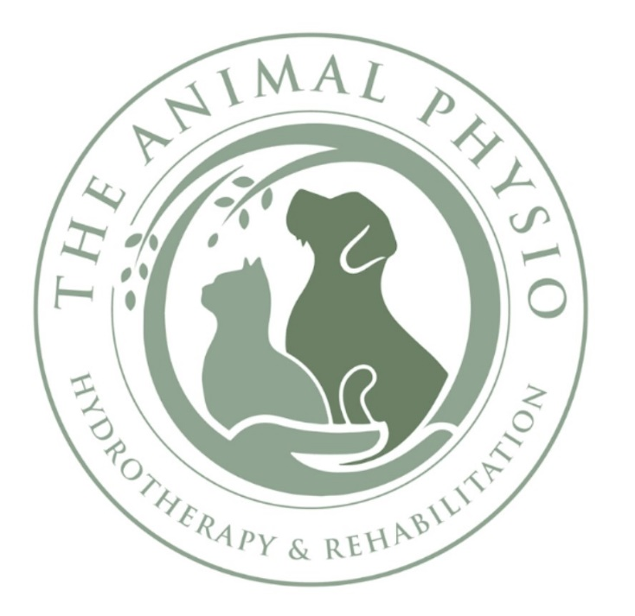
The Animal Physio

Teresa McAdam

B.Sc (Hons). Dip Animal Physio.

Registered Canine Hydrotherapist

IAAT, IRVAP (CH and MT)

Terms & Conditions
Our commitment is to provide you with a professional, caring and friendly service.
We request you read the Terms below and confirm you accept these by signing the form on or before your first visit.
- All animals treated at The Animal Physio requires a signed and dated Veterinary Referral form. This can be found on the website or alternatively we will email it to your vet.
- Payment for clinical services is due on the day of the booked session. All sessions are priced at £35. Payment methods include online transfer or cash.
- We accept that you may occasionally need to cancel your booked appointment and our cancellation policy requires a 24 hour notice period. For cancelled appointments outside of this period or non-attendance, the session fee will be charged in full. This fee will be waivered in the event of an emergency. The Animal Physio will make all efforts to contact owners if an appointment needs to be changed or cancelled, but will not accept liability for any losses or damage.

The Animal Physio

Teresa McAdam

B.Sc (Hons). Dip Animal Physio.

Registered Canine Hydrotherapist

IAAT, IRVAP (CH and MT)

- If your animal has an infectious or contagious condition you are required to inform us and reschedule your appointment - the cancellation policy applies. If your bitch comes into season, you must inform us as she will be unable to attend any booked sessions until her season is over.
- It is important not to feed your dog 3 hours prior of a booked hydrotherapy session. You will be given specialist advice for protocols to follow post session.
- We have areas around the centre for you to toilet your dogs, please leave plenty of time for this on arrival and prior to your booked session. Please clear up after your dog.
- There are signposted parking facilities available. The Animal Physio is not responsible for any damage, theft or injury caused by persons using the car park.
- Please keep your dog on a collar and lead at all times in the car park area and centre. Although your dog may be generally well behaved, there could be other injured animals at the centre which could be overwhelmed or hurt by normal friendly dog behaviour.
- Please read and abide by the visitors health and safety information on entering the centre. You need to wear clean, sensible footwear,

The Animal Physio

Teresa McAdam

B.Sc.(Hons). Dip Animal Physio.

Registered Canine Hydrotherapist

IAAT, IRVAP (CH and MT)

especially in the wet room where water on the floor is unavoidable. We understand that at certain times of the year it can be a challenge to keep your animal mud free. We kindly request that you bring as clean a dog as possible to the centre.
- The Animal Physio has a responsible water management system and will maintain the highest water quality at all times with documentation on display in the centre. We test our water three times a day and have it externally tested by Biosearch in Belfast.

I have read and accept the above Terms and conditions.

Client Name: ______________________________
Client Signature: ___________________________
Date: ____________________________________

